**Badger Dungeon**

Instruction Booklet

Made for Badger 2040 W Devices.

You are a badger, on a quest. Delve into the dungeon in search of treasure. But what dangers lurk in every room as you explore deeper into the dungeon? How far you can go in Badger Dungeon!

# Stats

Floor: The current floor you are on. Monsters get harder as you delve into the dungeon, but so does the amount of treasure.

Health: Your health. Don’t die!

Attack: Your attack power. The higher the more damage you do.

Defense: Your toughness. Take less damage if you can.

Gold: Your treasure! Collect more to spend more in the shop.

# Dungeon Floor Legend

E – Entry room.

N – Nothing, an empty room.

T – Treasure room.

M – Monster room, prepare to fight!

S – Stairs to the next floor.

Move to adjacent rooms with the A, C, Up, and Down buttons. Press B to interact with treasure, monsters, and the stairs.

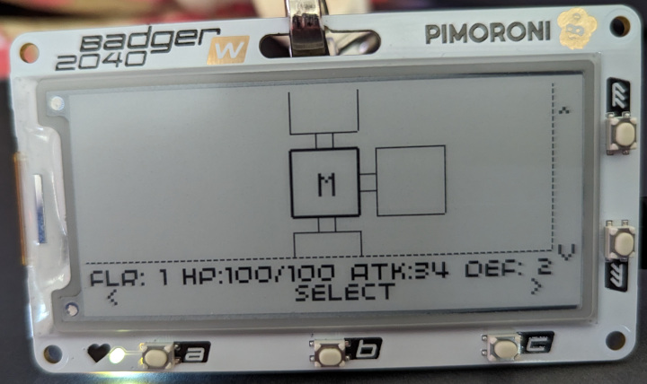

# Combat

Prepare to fight! Fend off attacks from the monster and defeat the monster before it defeats you! Collect some gold if you win.

### Actions

Attack: Standard attack, does half damage if the monster is blocking.

Block: Defend yourself! Take double damage if the monster does a heavy strike. Otherwise, gain a readiness multiplier to strike back at the monster.

Heavy Attack: Deal double damage against a blocking monster. Otherwise watch out if the monster does a standard strike.

Potion: Heal yourself for your healing amount.

# Monsters

The simple slime. Watch out for its attacks! It also sometimes blocks.

The turtle! It has high defense. It blocks a lot and does heavy strikes.

Ah, the goblin! Watch out for the attacks and heavy strikes!

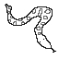

Argh! Snake, a snake! Snaaake! A snaaaake, ooh it’s a snake!

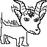

A fiery hellhound!



There are other monsters lurking in the dungeon so watch out. There may even be a dragon!

# Shop

Visit the shop at the end of the floor. Spend gold to upgrade your attack, defense, or potion for healing.

You also drink your potion when you get to the next floor and visit the shop!

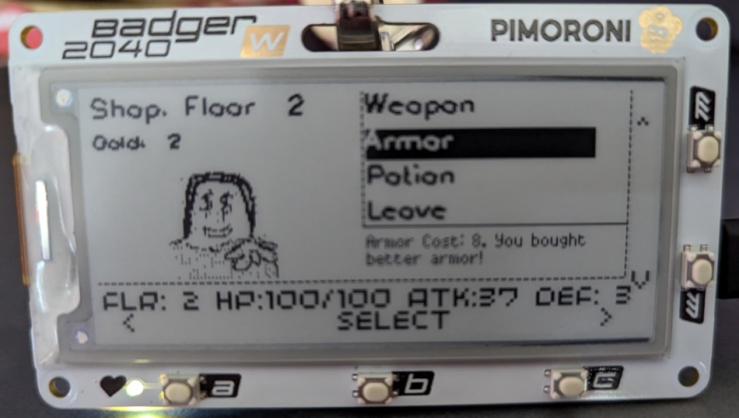

# Credits

Made by Judah Perez

Hellhound based on Nextament’s character, Luci

Dungeon gate icon - Delapouite under CC BY 3.0 <https://game-icons.net/1x1/delapouite/dungeon-gate.html>

# Notes

____________________________________________________________________________________________________________________________________________________________________________________________________________________________________________________________________________________________________________________________________________________________________________________________________________________________________________________________________________________________________________________________________________________________________________________________________________________________________________________________________________________________________________________________________________________________________________________________________________________________________________________________________________________________________________________________________________________________________________________________________________________________________________________________________________ ______________________________________________________________________________________________________________________________________________________________________________________________________________________________

____________________________________________________________________________________________________________________________________________________________________________________________________________________________________________________________________________________________________________________________________________________________________________________________________________________________________________________________________________________________________________________________________________________________________________________________________________________________________________________________________________________________________________________________________________________________________________________________________________________________________________________________________________________________________________________________________________________________________________________________________________________________________________________________________________

Thanks for Playing!

[Draw Badger Here] 🦡